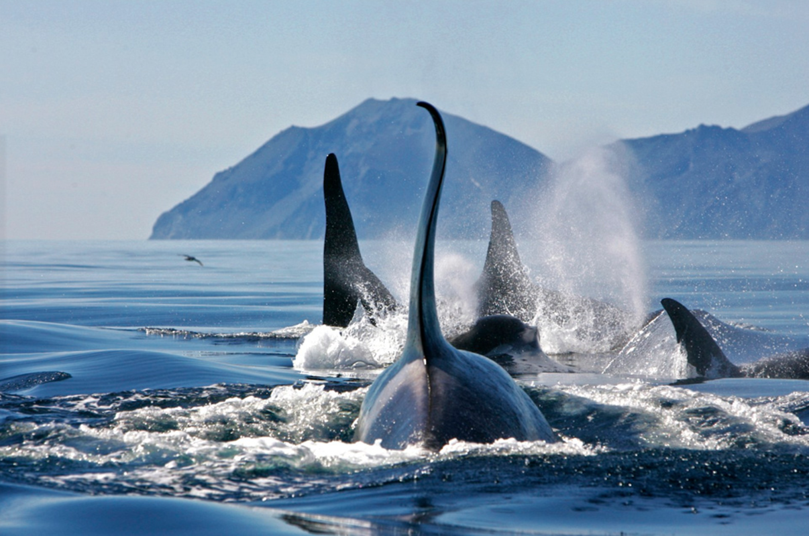
The Pod

The pod travelled everywhere together. Moving as one through the ice-cold, northern waters, they began to stalk their prey…

TASK: to complete this story using the story starter above, about a pod of killer whales (orcas).
You may wish to research these beautiful animals in order to assist your writing. What is their prey? Which oceans/seas do they live in? How many are in their pod? Who is in their pod? How do they hunt?

