$\frac{2}{3}$ of £81 is £27
Correct Not Correct
Explain_____________________________________________________________________________

$\frac{2}{5}$ of £66 is £13
Correct Not Correct
Explain______________________________________________________________________________

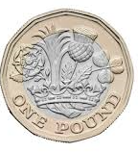
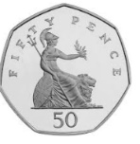
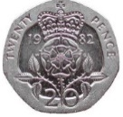
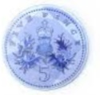
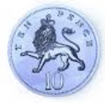
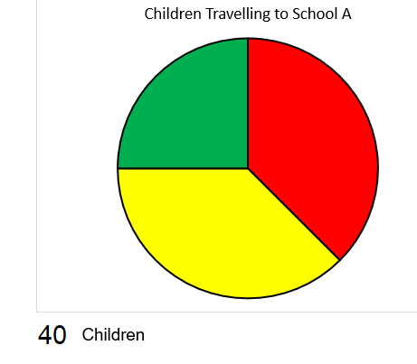
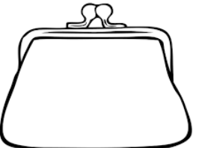
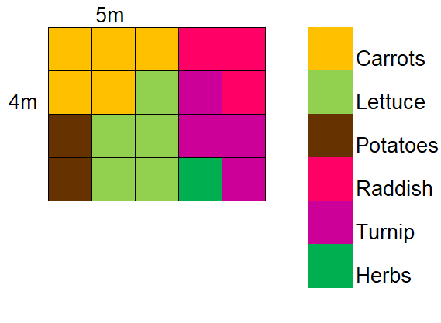
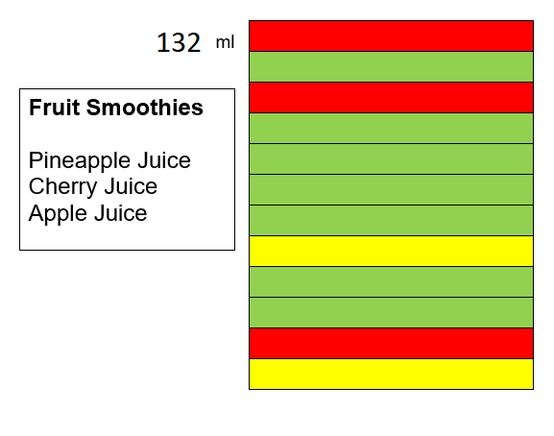
The green section represents the children who walk to school.
Tim Says, “4 children walk to school.” Is he correct? Explain.
_____________________________________________________________________________

The cherry juice is 44ml.
Correct
Not Correct
Explain_____________________________________________________________________________________________________________________________________

The carrots take up 6m²
Correct
Not Correct
Explain_____________________________________________________________________________

$\frac{1}{5}$ of the money is 35p
Correct
Not Correct
Explain_____________________________________________________________________________

