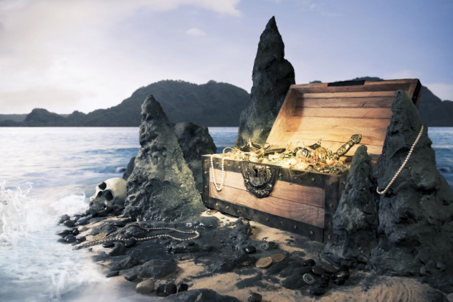
Write 3 sentences about each picture. Make sure you start each sentence in a different way. Add extra information to your sentences to make them interesting and effective.

A picture of a treasure Chest on an island

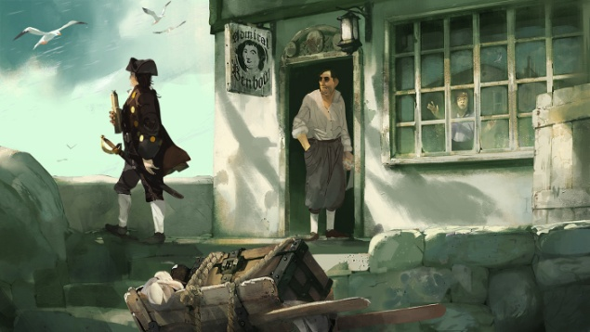
A picture of the Admiral Benbow (an inn from the book, Treasure Island)

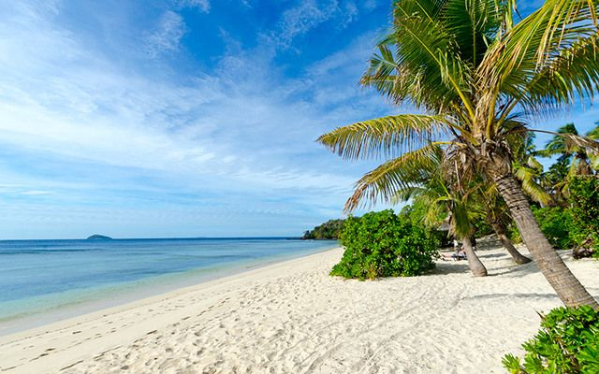

A picture of a desert island

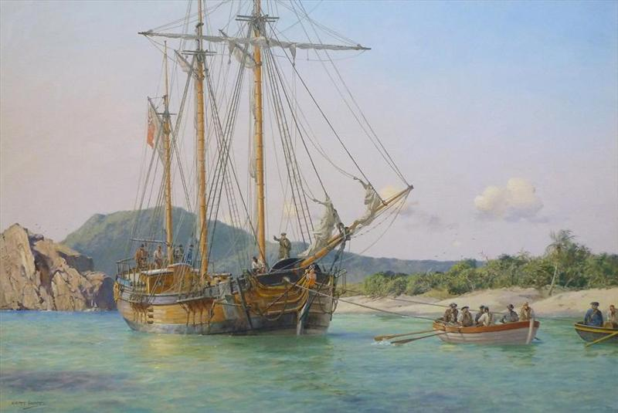

A picture of the Hispaniola (the ship from Treasure Island)

