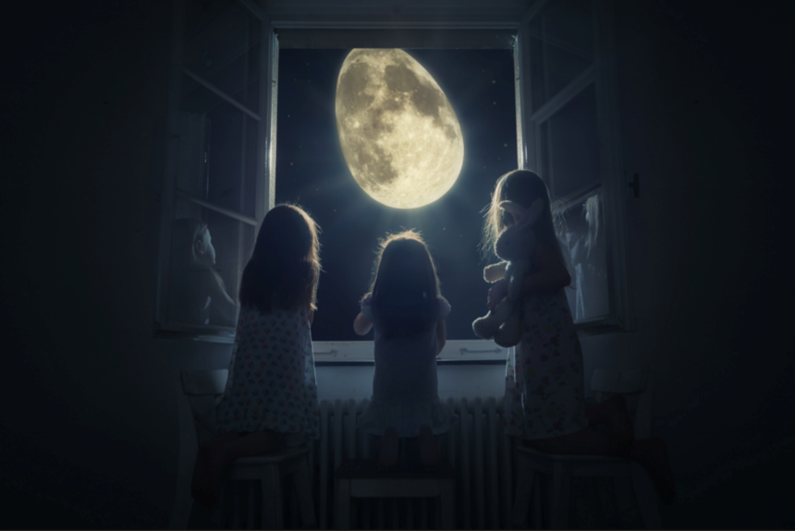
Oval-Shaped

Question time! – Consider these questions before your writing, they may help with your story.
Who are the girls in the picture?
Where are they?
What woke the girls from their sleep?
Why did they drag the chairs across the room ‘carefully’?
What can they see when they look out of the window?
What do you think might be happening?
Do they see anything else peculiar as they look out?

Story starter! – complete the rest of the story.
The girls huddled together and peered cautiously out of their bedroom window. They had been awoken, just moments earlier, by a strange light that burst through their curtains, filling the room with a silvery, white hue.
As one, they had tip-toed towards the source of the distraction, carefully dragging chairs across the room with them so that they could take a peek together.
They stared in awe and wonder at the sight that met their eyes. Something magical was happening…

