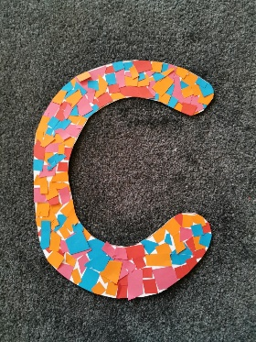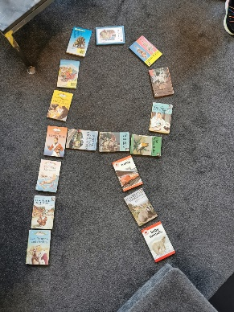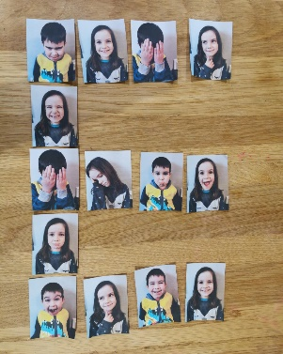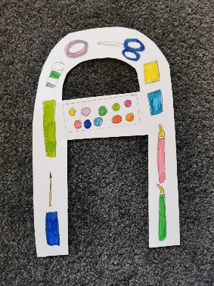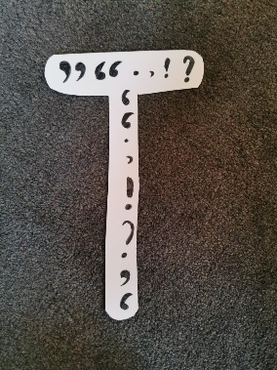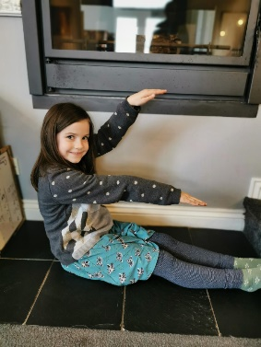

C is for collage. We like being creative with lots of different materials.
R is for reading. If you read lots of books, it helps you creativity grow.
E is for expression. Using your feelings helps you to create paintings, drawings, dramas and even songs to represent each emotion.
A is for art and all of the materials that help us create masterpieces!
T is for talking. Use your voice to sing, act or tell someone a story.
E is for express yourself. Using movement you can be as creative as you like!

